# Introduction

Sugar cane juice is a type of beverage extracted from pressed sugar cane. The drink can be obtained easily from places where sugar cane is commercially grown, such as Brazil, India and South East Asia. The simplicity of the production process makes it a popular choice for street vendors and hawkers. The drink is served chilled, making it a refreshing beverage for a tropical climate.

Despite its sweetness, research has shown that the juice is healthy as it is rich in nutrients and antioxidants, making it an ideal dessert for the health-conscious. The drink is also known to boost immunity and even cure bad breath. The drink has been shown have minimal impact on a person’s glucose level, allowing diabetics to enjoy it as well.

Although it is possible to manually extract sugar cane juice, oftentimes a sugar cane crusher is used to simplify the task and perform the process at a faster rate. The machine uses two rollers in tandem to crush the sugar cane stalk and extract the juice. The process is repeated until the sugar cane is squeezed dry. The necessary calculations must be made to optimize this process and create an efficient sugar cane crusher.

# Objective

The report aims to design a sugar cane juice extraction machine using a 0.25kW AC single phase motor operating at approximately 1420 rpm with a roller speed running at 55rpm. The machine will be using a combination of spur gears and a belt drive system to achieve the desired roller speed. The drive system will be contained within a space of 750x750x1300mm. Below are the assumptions we made while designing the system.

Assumptions:

1. The assigned motor power is assumed to be fully utilized with zero power loss.
2. Load due to weight of different components are assumed to be negligible.
3. Distributed loading will be approximated as point force due to distributed loading acting on a small area.

# Design and analysis

## Motor selection

The selected motor should be AC single phase motor with a power rating of 0.25kW and operating at approximately 1420rpm. A motor with 0.25kW operating at 1400rpm was selected to fit this requirement.

**From Appendix B**

Model number: MC801-4

Power output: 0.25kW

Rated speed: 1400rpm

Mount type: IBM3

## Transmission Design

The final rotational speed of roller is 55rpm while the motor speed is 1400rpm. Thus, we will be using a 4-stage speed reduction system to achieve optimal rotational speed and speed ratio while taking into consideration of the high stress that will act on the system should a 2-stage speed reduction is used.

$$SR= \sqrt[4]{\frac{input speed}{output speed}}= \sqrt[4]{\frac{1400rpm}{55rpm}}=2.25$$

$${{SR}_{overall}= SR}_{belt}∙{SR}_{gear 1-2}∙{SR}_{gear 3-4} ∙ {SR}_{gear 5-6}$$

$Final rotational speed= \frac{1400}{{2.25}^{4}} =54.63rpm$

This is a good assumption as final rotational speed is 54.63rpm which is 0.67% deviation from 55rpm. Therefore, we will be using a speed ratio of 2.25 and final rotational speed of 54.63rpm for our calculations for determining sizing, selection of materials and correct models.

## Belt Selection

**Step 1: Determine the design power**

From Table A-2(Appendix A), Service factor (AC normal torque, less than 10hrs/day, machinery)

S.F. = 1.1

Design Power = 1.1 x 0.25kW = 0.275kW

**Step 2: Select the proper V-belt Cross Section**

From Table A-3(Appendix A), design power of 0.275kW and 1400 rpm of faster shaft gives SPZ belt cross section.

**Step 3: Select the Sheave Diameter**

Assume belt speed, vb = 10m/s

DA = = = 0.136m

From Table A-4(Appendix A) for SPZ belt, Standard DA = 0.14m = 140mm

vb = rw1 = 0.07 x = 10.26 m/s ( > 5m/s and < 33 m/s)

$∴$ DA = 140mm

SR = $\frac{D_{B}}{D_{A}}$ $∴$ DB = 315mm

**Step 4: Select Centre Distance and Belt Pitch Length**

Let C be centre distance

Since 315mm < C < 1365mm (3(315 + 140))

Let Tentative Centre Distance (TCD) = 0.84m (Average of the range)

Tentative Belt Length, TBL

TBL = 2 x TCD + 1.57(DB + DA) +

= 2.40m

From Table A-1(Appendix A), Standard Belt Length, L = 2360mm

Calculate Actual Centre Distance, C,

$$4\left(2.36\right)- 6.28\left(0.315+0.136\right)=6.58$$

$$C= \frac{6.58+ \sqrt{{6.58}^{2}-32{(0.315-0.14)}^{2}}}{16}=0.818m$$

**Step 5: Determine the Power Correction Factor**

$$θ={180}^{°}-2\sin^{-1}\left(\frac{0.315-0.14}{2\left(0.818\right)}\right)={167.7}^{°}$$

From Table A-5(Appendix A), Angle of Contact Correction Factor, $C_{θ},$

$$C_{θ}≈0.97$$

From Table A-6(Appendix A), Belt Length Correction Factor, $C_{L},$

$$C_{L}≈1.07$$

**Step 6: Determine the rated power (RP), kW per belt**

From Table A-7a (Appendix A), for DB=140mm, 1400 rpm and speed ratio of 2.25,

RP = 4.28 kW/belt

Step 7: Determine the corrected rated power (CRP), kW per belt

CRP = $C_{θ}C_{L} x RP=0.97 x 1.07 x 4.28=4.44kW$

**Step 8. Find the number of belts**

$$No of belts= \frac{Design Power}{Corrected Rated Power}= \frac{0.275}{4.44}=0.0619$$

$∴$ 1 SPZ belt is used, L = 2360mm, D1 = 140mm, D2 = 315mm

## Taper Lock Pulley Selection

For smaller sheave, DA = 140mm, under SPZ cross section from the Taper Lock Pulley Catalogue (Appendix A), Bush no. 1610 is selected.

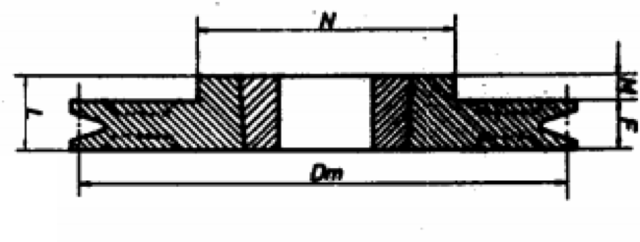

Figure 1: Taper Lock Pulley for Bush no. 1610

|  |  |  |  |  |  |  |  |  |
| --- | --- | --- | --- | --- | --- | --- | --- | --- |
| Pitch diameter | Groove | Bush. no | Max Bore (mm) | F (mm) | L (mm) | M (mm) | N (mm) | Weight |
| 140 | 1 | 1610 | 42 | 16 | 25 | 9 | 92 | 1.2 |

For the bigger sheave, DB = 315mm, under SPZ cross section from the Taper Lock Pulley Catalogue (Appendix A), Bush no 2012 is selected.

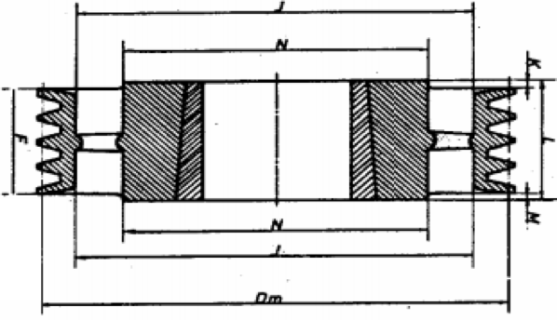

Figure 2: Taper Lock Pulley for Bush no. 2012

|  |  |  |  |  |  |  |  |  |  |  |
| --- | --- | --- | --- | --- | --- | --- | --- | --- | --- | --- |
| Pitch diameter | Groove | Bush. no | Max Bore (mm) | F  (mm) | J (mm) | K (mm) | L (mm) | M (mm) | N (mm) | Weight |
| 315 | 1 | 2012 | 50 | 16 | 286 | 8 | 32 | 8 | 112 | 3.1 |

**Taper Lock Bush Selection**

From the Taper Lock Pulley Catalogue (Appendix A),

|  |  |  |
| --- | --- | --- |
|  | Smaller Sheave | Larger Sheave |
| Bush No | 1610 | 2012 |
| Bore (mm) | 16 | 16 |
| Keyway Width (mm) | 5 | 5 |
| Keyway depth at centre (mm) | 2.3 | 2.3 |
| Diameter at large end of taper (mm) | 57 | 57 |

## Gears Selection

Since there is no power loss throughout the whole system, Effective Power, Peff = 0.25kW. Taking into account that the application of sugar cane machine is of normal importance, from Appendix B, Safety Factor, SB = 1.25. Since we are expecting a uniform loading driven uniformly, Service factor, fB = 1.0.

Heat treated spur gears is chosen because it has higher strength and needed for small gear size calculation. Heat-treatable steel C 45 or high-strength special steel ETG 100 from Z-056 Load diagram (Appendix B) will be used in the calculation of module(m).

From Spur Gears Catalogue (Appendix B),

$$P_{tab}= P_{eff} * S_{B} * f_{B}=0.25*1.25*1.0$$

$$P_{tab}=0.3125kW$$

|  |  |  |  |  |
| --- | --- | --- | --- | --- |
| Speed Reduction Stage | Speed ratio, SR, | Input Speed, $η$, (RPM) | Output Speed, $η$, (RPM) | Torque, T, (Nm)  T = $\frac{P_{tab}}{(ω/60)x2π }$ |
| 1st stage(Gear 1 and 2) | 2.25 | 622.22 | 276.54 | 4.80 |
| 2nd stage(Gear 3 and 4) | 2.25 | 276.54 | 122.91 | 10.79 |
| 3rd stage(Gear 5 and 6) | 2.25 | 122.91 | 54.63 | 24.28 |

Let N be the number of teeth for Gears,

**1st Stage speed reduction**

Take N1 = 24T, T1=4.6Nm, = 622.22rpm

From Z-056 Load diagram (Appendix B), m = 1.

N2 = SR x N1 = 2.25 x 24 = 54T, T2=10.79Nm,

From Z-056 Load diagram (Appendix B), m = 1.

From Z – 103 of Spur Gear catalogue (Appendix B), N1 = 24T (Sg 1024) and N2 = 54T (Sg 1054) are chosen for 1st stage speed reduction.

Check: $η_{2}= {\frac{N_{1}}{N_{2}} η}_{1} = \frac{24}{54}$ x 622.22 = 276.54rpm (speed output required)

**2nd Stage speed reduction**

Take N3 = 24T, T3 = T2 = 10.79Nm, $η_{3}=η_{2}$ = 622.22rpm (same shaft)

From Z-056 Load diagram (Appendix B), m = 1.5.

N4 = SR x N3 = 2.25 x 24 = 54T, T4 =24.28Nm,

From Z-056 Load diagram (Appendix B), m = 1.5.

From Z – 106 of Spur Gear catalogue (Appendix B), N3 = 24T (Sg 1524) and N4 = 54T (Sg 1554) are chosen for 2nd stage speed reduction.

Check: $η_{4}= {\frac{N_{3}}{N_{4}} η}_{3} = \frac{24}{54}$ x 276.54 = 122.91rpm (speed output required)

**3rd Stage speed reduction**

Take N5 = 24T, T5=T4=24.28Nm, $η_{5}=η_{4}$ = 122.91rpm (same shaft)

From Z-056 Load diagram (Appendix B), m = 2.

N6 = SR x N5 = 2.25 x 24 = 54T, T6 =54.63Nm,

From Z-056 Load diagram (Appendix B), m = 2.

From Z – 108 of Spur Gear catalogue (Appendix B), N5 = 24T (Sg 2024) and N6 = 54T (Sg 2054) are chosen for 3nd stage speed reduction.

Check: $η_{6}= {\frac{N_{5}}{N_{6}} η}_{5} = \frac{24}{54}$ x 122.91 = 54.63rpm (speed output required)

|  |  |  |  |  |  |  |
| --- | --- | --- | --- | --- | --- | --- |
| Gear | Part number | Module, m | Number of teeth, N | Pitch diameter (mm) | Outer diameter (mm) | Thickness (mm) |
| 1 | Sg 1024 | 1 | 24 | 24 | 26 | 12.5 |
| 2 | Sg 1054 | 1 | 54 | 54 | 56 | 14.5 |
| 3 | Sg 1524 | 1.5 | 24 | 36 | 39 | 24 |
| 4 | Sg 1554 | 1.5 | 54 | 81 | 84 | 26 |
| 5 | Sg 2024 | 2 | 24 | 48 | 52 | 31 |
| 6 | Sg 2054 | 2 | 54 | 108 | 112 | 31 |

## Force analysis

**Belt (Free Body Diagram and Force Calculations)**

Allowing for centrifugal force, Fc, due to inertia effect of the belt, the belt tension ratio can be obtained from:

$$\frac{F_{1}-F_{c}}{F_{2}-F_{c}}=e^{θ_{1}f/\sin{β}} where F_{c}=mv_{b}^{2}$$

Assuming no power loss, TA =

From Table A-1 (Appendix A), Standard Cross Section and Mass,

SPZ belt has 0.070kg/m

From belt analysis, vb = 10.26m/s

$$F_{c}=mv_{b}^{2}=0.07*{10.26}^{2}=7.37N$$

Since diameter of smaller sheave, D1 = 140mm, from Table A-8, effective coefficient of friction,

Fe = 0.4 where Fe =

Driven pulley on shaft

On Driven pulley

On Driver pulley

TB

Fa

F2

F1

TA

Fa

F2

F1

TB

Fa

Angle of contact on smaller sheave, $θ_{1}={167.7}^{°}=2.93rad$

$$F_{1}=F_{c}+2\left(\frac{γ}{γ-1}\right)\frac{T_{A}}{D_{1}} where γ= e^{θ_{1}f/\sin{β}}$$

$$γ=e^{2.93*0.4}=3.2284$$

$$F_{1}=7.37+2\left(\frac{3.2284}{3.2284-1}\right)\frac{1.705}{0.140}=42.66N$$

$$F_{2}=\frac{42.66-7.37+3.2284*7.37}{3.2284}=18.3N$$

$$F_{a}=42.66+18.3=60.96N$$

**Gears (Free Body Diagram and Force Calculations)**

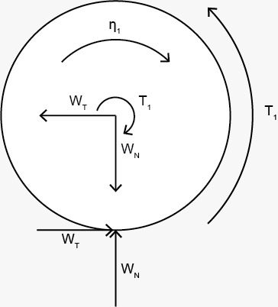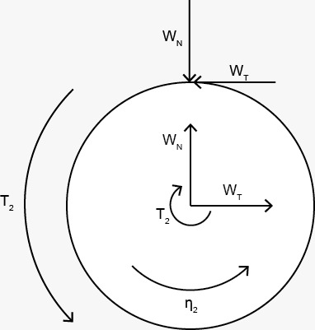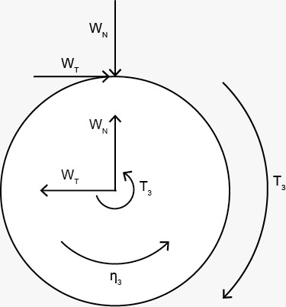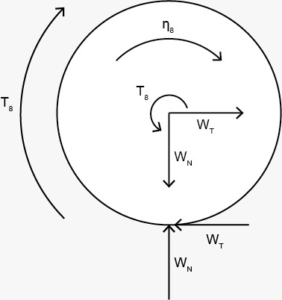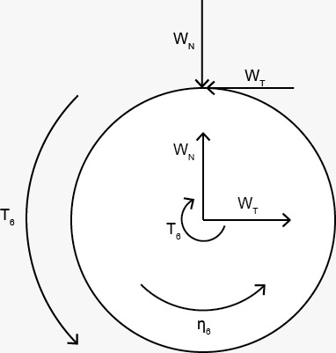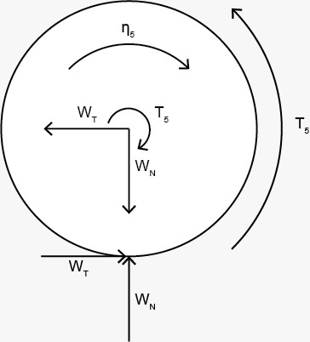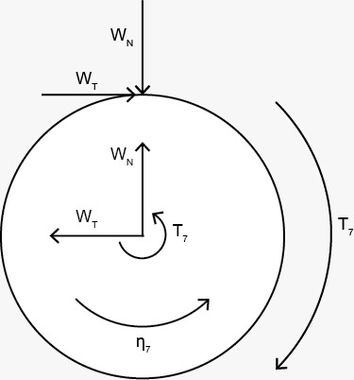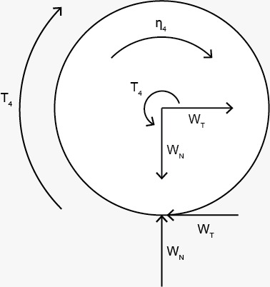

For all calculations of Gears,

$$T=\frac{P}{ω}$$

Tangential force, $W_{t}=\frac{T}{r}$ where T is torque and r is the radius of gear

Radial force, $W_{r}=W_{t} \tan{{20}^{°}}$

For Gear 1, $T_{1}=\frac{250}{\frac{622.22}{60}*2π}=3.84Nm$, Diameter, D1=24mm

For Gear 2, , Diameter, D2=54mm

For Gear 3, , Diameter, D3=36mm

For Gear 4, , Diameter, D4=81mm

For Gear 5, , Diameter, D5=48mm

For Gear 6, , Diameter, D6=108mm

For gear 7 and 8, they both must have a rotational speed of 54.63rpm since they have to allow the rollers to rotate at same speed. Assuming that the roller must have diameter of 100mm and 10mm gap, the center distance between the gears 7 and 8 must be 110mm. Thus, the diameter of each gear with 55mm and a module of 2 was chosen.

For Gear 7, $T_{7}=\frac{125}{\frac{54.63}{60}*2π}=21.85Nm$, Diameter, D7=110mm

For Gear 8, , Diameter, D8=110mm

**Roller (Free Body Diagram and Force Calculations)**

TR

Assume point force, an coefficient of roller

TR = T6 = 21.85Nm, D=100mm

$$W_{t}=\frac{21.85}{0.05}=437N$$

Normal Force,

$$W_{N}=\frac{W_{t}}{μ_{R}}=\frac{437}{0.5}=874.1N$$

## Shaft Design

There are five shafts for the design with different components connected on it.

|  |  |
| --- | --- |
| Shaft Number | Connections |
| 1 | Driven Pulley -> Bearing A -> Bearing B -> Gear 1 |
| 2 | Gear 2 -> Bearing C -> Bearing D -> Gear 3 |
| 3 | Gear 4 -> Bearing E -> Bearing F -> Gear 5 |
| 4 | Gear 6 -> Bearing G -> Roller 1 -> Bearing H -> Gear 7 |
| 5 | Gear 8 -> Bearing I -> Roller 2 -> Bearing J |

Below is the calculation for shaft 4 because it is the most complicated shaft with most forces. It is assumed that the point load exerted by the components on the shaft is on the mid-span of the shaft. The shaft design calculations for the rest of the shafts are in the appendix.

**Force analysis of shaft 4**

Assumptions: (1) Bearing and gears have negligible weight,

(2) Rollers are welded on the shafts.

(3) Length of shaft to be 400mm

Gear 6: $W_{t6}=809.32, W_{r6}=294.6N$,

Gear 7: $W_{t7}=397.3N, W_{r7}=114.6N$

Roller: $W_{tR}=437N, W_{NR}=874N$.

**Step 1: Find Forces on Bearing G and H in y and z-axis**

Z-Axis

Take clockwise as positive,

$ΣM_{GZ}=0,$

$${-W}_{t7}*0.375-F_{HZ}*0.35-W_{tR}*0.175-W_{t6}*0.025=0$$

$$F_{HZ}=-701.99N$$

$$ΣF_{Z}=0,$$

$F_{GZ}=677.01N$

Y-Axis

Take clockwise as positive,

$ΣM_{Gy}=0,$

$${-W}_{r7}*0.375+F_{Hy}*0.35-W_{NR}*0.175+W_{r6}*0.025=0$$

$$F_{Hy}=538.74N$$

$$ΣF_{y}=0,$$

$$F_{Gy}=744.46N$$

**Step 2: Load, Shear Force, Bending Moment diagram**

X-Z Plane X-Y Plane

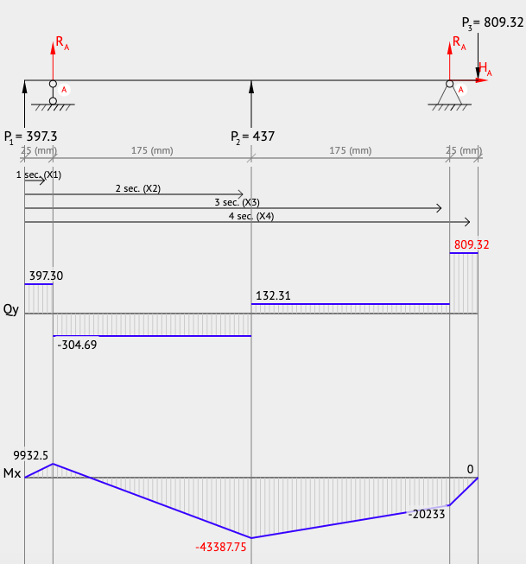 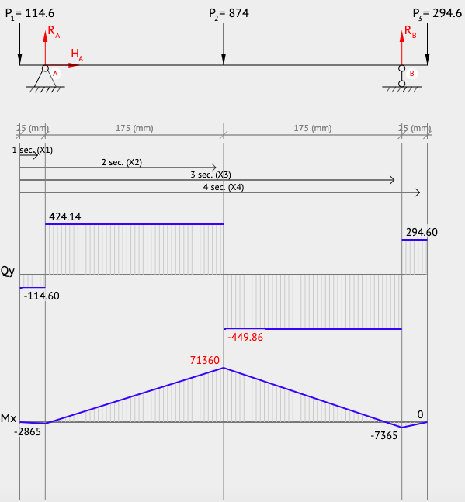

**Step 3: Resultant moment and Torque**

$ΣM_{6}=0$,

$$ΣM_{G}=\sqrt{(-{20.233)}^{2}+(-7.365)}=21.53Nm$$

$$ΣM_{R}=\sqrt{(-{43.388)}^{2}+(71.36)}=83.19Nm$$

$$ΣM_{H}=\sqrt{({9.933)}^{2}+(-2.865)}=10.57Nm$$

$$ΣM_{7}=0$$

Torque: (Gear 7)21.85 - > 21.85 -> 21.85(left of roller) -> 43.7(right of roller) -> 43.7 -> 43.7(Gear 6)

**Step 4: determine shaft diameter**

SAE number 1137 Cold-drawn alloy steel (Appendix C) is chosen as the shaft material for shaft 1, 4 and 5 because it has higher strength, direct hardening and is suitable for higher stress applications.

Material: SAE 1137 alloy steel

Condition: Cold-drawn

Tensile strength, Su: 676MPa, Yield Strength, Sy: 565MPa and Endurance strength, Sn= 280MPa.

Assume $C_{s}$ = 0.82, $C_{r}$ =0.91(99% reliability).

$$S_{n}^{'}={S_{n}*C}_{s}*C_{r}$$

To find diameter,

$$D={(\frac{32N}{π}\sqrt{{\left(\frac{K_{fb}M}{S_{n}^{'}}\right)}^{2}+\frac{3}{4}{\left(\frac{T}{S_{y}}\right)}^{2}})}^{1/3}$$

|  |  |  |  |  |  |  |  |
| --- | --- | --- | --- | --- | --- | --- | --- |
| Location | Component | Kfb | M  (Nm) | T(Nm) | Min Diameter(mm) | Updated $C_{s}$ | Updated Diameter (mm) |
| Left of Gear 7 | Retaining ring | 3.0 | 0 | 21.85 | 10.08 | 0.97 | 10.77 |
| Center of Gear 7 | Profile Key | 2.0 | 0 | 21.85 | 10.08 | 0.97 | 10.77 |
| Right of Gear 7 | Well-rounded | 1.5 | 0 | 21.85 | 10.08 | 0.97 | 10.77 |
| Left Bearing H | Well-rounded | 1.5 | 10.57 | 21.85 | 13.60 | 0.94 | 13.14 |
| Center bearing H | Press fit | 1.0 | 10.57 | 21.85 | 12.28 | 0.95 | 11.9 |
| Right bearing H | Sharp fillet | 2.5 | 10.57 | 21.85 | 15.87 | 0.92 | 15.3 |
| Left of Roller | Welded | 1.0 | 83.19 | 21.85 | 23.02 | 0.89 | 22.45 |
| Center of Roller | Welded | 1.0 | 83.19 | 43.7 | 23.11 | 0.88 | 22.54 |
| Right of Roller | Welded | 1.0 | 83.19 | 43.7 | 23.11 | 0.88 | 22.54 |
| Left of Bearing G | Sharp fillet | 2.5 | 21.53 | 43.7 | 20.11 | 0.90 | 12.55 |
| Center of Bearing G | Press fit | 1.0 | 21.53 | 43.7 | 15.54 | 0.92 | 15.13 |
| Right of Bearing G | Well-rounded | 1.5 | 21.53 | 43.7 | 17.27 | 0.91 | 16.76 |
| Left of Gear 6 | Well-rounded | 1.5 | 0 | 43.7 | 12.70 | 0.95 | 12.70 |
| Center of Gear 6 | Profile key | 1.5 | 0 | 43.7 | 12.70 | 0.95 | 12.70 |
| Right of Gear 6 | Retaining ring | 1.5 | 0 | 43.7 | 12.70 | 0.95 | 12.70 |

To support the shafts and ensure smooth rotation within the designed sugar cane crusher, 10 bearings are used. The bearings are selected from the catalogue (Appendix D) for single row deep groove ball bearings. A sample calculation for bearing G is included below to describe the bearing selection method, followed by the bearing selections for the other 9 bearings used. The design is assumed a design life of 10 years and usage of 8hours/day. To choose the bearing, both shaft diameter and dynamic load are taken into consideration.

L10 = 10 x 365 x 8 = 29200 hours

At shaft 4, n = 54.63rpm,

$$L_{d} = L_{10}*n*60 = 29200*54.63*60 = 9.57* {10}^{7} h$$

Basic dynamic load Ccalculated =

From catalogue (Appendix D),

$$C_{catalogue}>4.60kN(C_{calculated})$$

$$D_{catalogue}>16.76mm(D_{min})$$

Therefore, we select bearing 6004, bore diameter = 20mm, C = 9.36kN

|  |  |  |  |  |  |
| --- | --- | --- | --- | --- | --- |
| **Bearing** | **Static Loading (Pd)** | **Basic Dynamic Load rating**  **(Ccalculated)** | **Min diameter (mm)** | **Bearing no.** | **Bore diameter (mm)** |
| A | 762.66 | 7849 | 9.8 | 6004 | 20 |
| B | 569.29 | 5859 | 16.5 | 6004 | 20 |
| C | 1519 | 1190 | 12.4 | 6204 | 20 |
| D | 1698 | 1370 | 14.2 | 6204 | 20 |
| E | 2410 | 1445 | 14.3 | 6304 | 25 |
| F | 2700 | 1670 | 17.06 | 6307 | 25 |
| G | 1005 | 4600 | 19.55 | 6004 | 20 |
| H | 904 | 4100 | 15.3 | 6004 | 20 |
| I | 627 | 2869 | 14 | 6004 | 20 |
| J | 492.98 | 2260 | 20 | 6004 | 20 |

## Key Design

Key selection:

Initial assumptions: SAE 1117 cold drawn steel (Sy=448MPa) is selected for key material as it has a lower yield strength than SAE 1137 (Sy=565MPa) cold drawn steel, which is the material used for the shafts, the safety factor N is assumed to be 3. Final key length is based on table 11-1 (Appendix E).

|  |  |  |  |  |  |  |  |
| --- | --- | --- | --- | --- | --- | --- | --- |
| Key | Feature at key location | Shaft diameter (mm) | Key width (mm) | Key height (mm) | T (Nm) | Minimum key length (mm) | Final key length (mm) |
| 1 | Gear 1 | 6 | 2 | 2 | 3.84 | 8.6 | 10 |
| 2 | Gear 2 | 6 | 2 | 2 | 8.63 | 19.3 | 20 |
| 3 | Gear 3 | 6 | 2 | 2 | 8.63 | 19.3 | 20 |
| 4 | Gear 4 | 12 | 4 | 4 | 19.42 | 10.8 | 12 |
| 5 | Gear 5 | 12 | 4 | 4 | 19.42 | 10.8 | 12 |
| 6 | Gear 6 | 15 | 5 | 5 | 43.7 | 15.6 | 16 |
| 7 | Gear 7 | 15 | 5 | 5 | 21.85 | 7.8 | 8 |
| 8 | Gear 8 | 15 | 5 | 5 | 21.85 | 7.8 | 8 |

Key calculations:

Key 1 is mounted on a 6mm shaft, thus a 2mm by 2mm square key is selected,

$$L_{min}=\frac{4TN}{DWS_{y}}=\frac{4*3.84Nm*3}{0.006m*0.002m*448*{10}^{6}Pa}=8.6mm$$

Key 2 is mounted on a 6mm shaft, thus a 2mm by 2mm square key is selected,

$$L_{min}=\frac{4TN}{DWS_{y}}=\frac{4*8.63Nm*3}{0.006m*0.002m*448*{10}^{6}Pa}=19.3mm$$

Key 3 is mounted on a 6mm shaft, thus a 2mm by 2mm square key is selected,

$$L_{min}=\frac{4TN}{DWS_{y}}=\frac{4*8.63Nm*3}{0.006m*0.002m*448*{10}^{6}Pa}=19.3mm$$

Key 4 is mounted on a 12mm shaft, thus a 4mm by 4mm square key is selected,

$$L_{min}=\frac{4TN}{DWS_{y}}=\frac{4*19.42Nm*3}{0.012m*0.004m*448*{10}^{6}Pa}=10.8mm$$

Key 5 is mounted on a 12mm shaft, thus a 4mm by 4mm square key is selected,

$$L_{min}=\frac{4TN}{DWS_{y}}=\frac{4*19.42Nm*3}{0.012m*0.004m*448*{10}^{6}Pa}=10.8mm$$

Key 6 is mounted on a 15mm shaft, thus a 5mm by 5mm square key is selected,

$$L_{min}=\frac{4TN}{DWS_{y}}=\frac{4*43.7Nm*3}{0.015m*0.005m*448*{10}^{6}Pa}=15.6mm$$

Key 7 is mounted on a 15mm shaft, thus a 5mm by 5mm square key is selected,

$$L_{min}=\frac{4TN}{DWS_{y}}=\frac{4*21.85Nm*3}{0.015m*0.005m*448*{10}^{6}Pa}=7.8mm$$

Key 8 is mounted on a 6mm shaft, thus a 2mm by 2mm square key is selected,

$$L_{min}=\frac{4TN}{DWS_{y}}=\frac{4*21.85Nm*3}{0.015m*0.005m*448*{10}^{6}Pa}=7.8mm$$

## Conclusion

By utilizing the concepts learned in MA3001, our group has managed to come up with this finalized sugar cane crusher design. This has been accomplished by collaborating our efforts in both calculation and 3d modelling of the sugar cane crusher with AutoCAD. The necessary calculations and assumptions for all parts of the sugar cane crusher, from the selection of gears to the design of shafts, have been provided here and in the appendix. Our final sugar cane design fits well within the required requirements in terms of both size, power and output speed. The lessons we have learned in MA3001 were applied with great success into the project and will prove to be a useful foundation for our engineering knowledge once we enter the workforce as engineers.